WEEK 1

# Admin Dashboard Page using HTML and CSS

Aim: To build an admin dashboard responsive page

Languages used: HTML, CSS and JavaScript

Software Used: Visual Studio

This week we focused on using our HTML and CSS and java script skills for building an admin dashboard website. There was a small course of few hours for HTML and CSS for basic introductory coding needed for the website building.

There was a specific template to be followed for building the website. This was a basic to intermediate website building. Although there wasn’t complex coding, the code was lengthy and thus almost took a week to complete.

The project was both fun and irritating at the same time. Building the website was fun and interesting but even a small mistake would mess up the whole page at times and that’s where I learnt most of the language. The errors would help me understand HTML and CSS in a way I never did before.

My mentor Rocky Sir helped a lot in the queries and errors during the project building. He played an important role solving my errors without which I would have given up an hour into building the project.

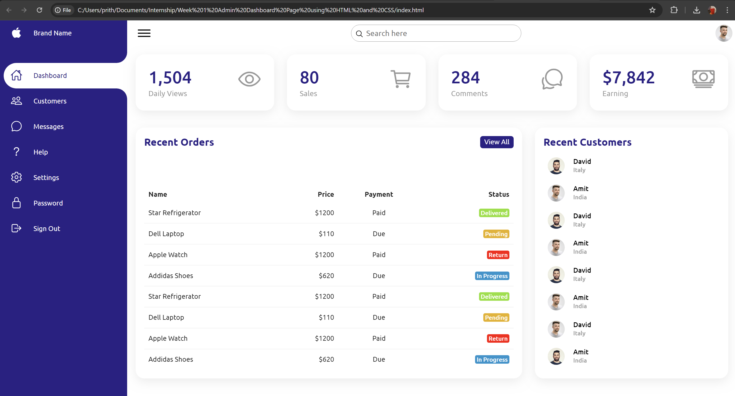

This is a screenshot of the website that I built. It is just a simple website with no hyperlinks on the elements. It is a dashboard of an Admin which contains the orders and customers in a list manner and the daily views and sales as well as the earnings and comments on the top in a rectangular board.

The highlight of this project is the responsive side panel which contains various options. When the three flat lines on the top left of the website is clicked, the side panel merges to the left end and closes into itself with just the icons visible and when clicked again it opens back out. This is a useful feature for the admin when more screen space is needed in the main content of the website.

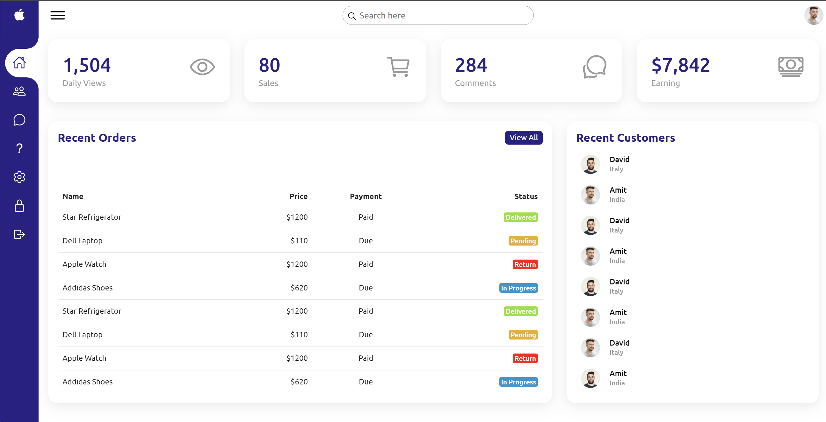

We can see in this picture above of my website, the side panel is merged in and the icons are still visible. This creates more room for the main content page of the website. Another click and the side panel opens out again.

In conclusion this website building project was focused mainly on the design side and look and feel of the website. Although the project feels small the code was lengthy and took time for a beginner like myself.

The code and all elements used has been uploaded separately in another folder in the drive.